**Future scope**

1. 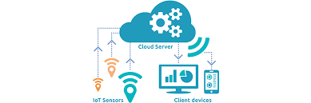The performance of the system can be future improves in terms of operating speed, memory, memory capacity and by using the arduino mega. The number of channels can be increase to interface more number of sensors so whole plant can be monitored
2. If the advancement made not only the one bath but whole plant can be monitored and can be controlled automatically eg if the Ph value of certain bath goes beyond the level controller wil automatically dilute the electrolyte solution by actuating solonied valve of water and if goes below the level controller will add the electrolyte solution in it. In similar way it I applicable to temperature and other parameters.
3. 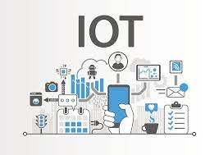In terms it can also be made compliance to IOT where the data collected can be send to cloud and can be monitored by Apk application or software. This can be done by interfacing the wsp8266 Wifi module which will give the internet access for the data storage
4. It can also be modified with the data logger to store the measure sensor data over a period of time
5. A speaking voice alarm could be used instead of the normal buzzer so it will dictate the exact value measured
6. This system can be connected to communication device such as modems, cellular phones or satellite terminal to enable the remote collection of recorded data or alarming of certain parameters
7. A self desister control provision can be implemented by taking considering the accident probability and chances making the system efficient to desister management
8. Owing towards the current industrial revolution movement industry 4.0 electroplating plant can be be given a remote access where electroplating plant can be made 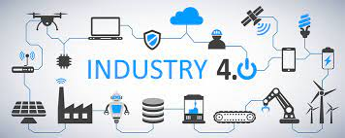independent and can access from the anywhere. It will be a step towards the automation.